Lesson
Watch 973 RAMP Designing robots with sketches video

Activity
Watch 2011 Logomotion Game Video

Draw a 2D sketch with a 2 link arm robot to play Logomotion with the following parameters:
- The entire robot has to be able to be folded up so that it is less than 60” tall and 48” wide
- Draw an arm for each of the following configuration. Make sure the arms have the same dimensions (use relations by selecting multiple lines and setting them equal to each other).
  - The end of the arm must be able to reach 0” (floor pick up)
  - The end of the arm must be able to reach 30” (low peg)
  - The end of the arm must be able to reach 60” (middle peg)
  - The end of the arm must be able to reach 90” (high peg)
For more info: 2011 Game Rules

Example (missing arm length):
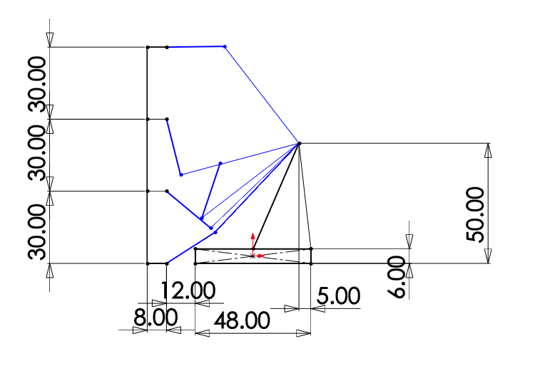
Each blue arm represents a certain position that it will take to score on that peg.

After finishing the activities, we compared what the students came up with and looked over what other teams did for the game.
Watch FRC 148’s 2011 Robot - “Arm” bot
Watch FRC 254’s 2011 Robot - “Lift” bot

